Display Control Documentation

Introduction
The display hardware is currently arranged in the following hierarchy:
- display_top (display_top.vhd)
  - u_display_control (display_control.vhd)
    - font ram (simple_dual_two_clocks.vhd)
Packages:
- pkg_vga_params_1280_1024_60hz.vhd
- pkg_vga_params_640_480_60hz.vhd
u_display_control takes in a pixelclk generated by a Clock Wizard IP core in display_top. It supports both 1280x1024@60Hz and 640x480@60Hz, with the output depending on which package is used in display_control.

Current issues:
All displayed char addresses are shifted by 1, so address 0 is displayed in the spot of address 1.

So when hcount_d2 =0-7, CHAR_ADDR = -1
when hcount_d2 =8-16, CHAR_ADDR = 0

CHAR_ADDR(0) and CHAR_ADDR(159) are the same character, starting at font_rom address 128

It looks like the problem is with taking an extra cycle to assert enb to read the new font row. This was leaving .
This messed up the character display, so lets revert that for now…
Our first row of image data is looking pretty screwed (need more v_count delay?, lets focus on fixing the second row of frame 2
Start by changing read_font_bit to be combinational – we don’t need to wait for ANOTHER enb to register it, as its coming straight out of the (registered) font memory.
This looks like we are now getting a proper looking character in all 4 corners of the screen. Now we just need to fix the first line of every frame.

Timing Issues:
To run at 108MHz required for 1280x1024, we need to pipeline a lot of the address calculation logic: -0.7ns of slack :(
Our clock period at 108MHz = 9.26ns
Clock period at 25MHz = 40ns
So we are taking ~9% too long, so not too bad tbh (max clock ~100MHz)

char_x <= to_integer(shift_right(to_unsigned(h_count, 32), 3)); -- 8 pixels width per char
char_y <= to_integer(shift_right(to_unsigned(v_count, 32), 4)); -- 16 pixels width per char
char_address <= char_y * CHARS_X + char_x;
lookup charcode_to_display from char_address
charcode_base_address <= shift_left(charcode_to_display, 4); -- charcode*16
addrb <= std_logic_vector(charcode_base_address + font_row);
There are several places to pipeline this here…
In that multiply looks like a good bet

First lets find the difference adding a Text RAM makes… as it would add an extra cycle in for us.
Text RAM: Requirements 10239 addresses for 1 frame (might as well go 16-bit, can support 3 frames worth of addresses)
8 bits for character 4 bits for foreground colour, 4 bits for background colour (map with colour RAM)
Per frame memory requirements: 10240 x 16 = 163,840 bits = 20,480 bytes (10Kb * 16)
This is acceptable for our 50 36Kb (2x18Kb) Block RAMs. We will need 5 of these.
They will be configured in 2Kx18bit mode, so we could extend later to 5 bit colours, or 6+4bit with no additional cost.
For now, lets not micromanage the memory allocation and let vivado handle it. We may wish to use separate memories for each component of the text.
So 16 bit address, 18 bit data, 10240 depth.

New Design for Text Mode:

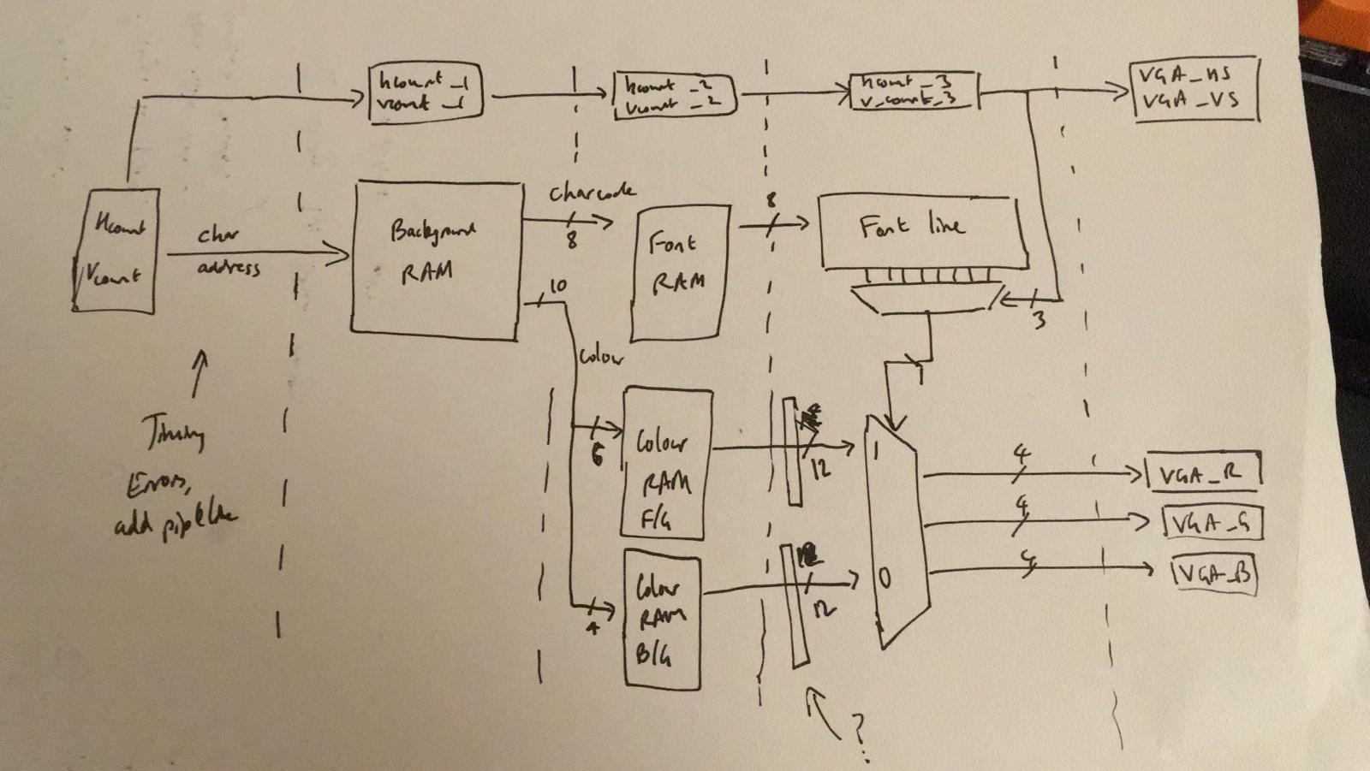
We are now using display_text_controller.vhd instead of display_control.vhd
With the additional pipelining of this new design, it will hit the 108MHz required for 1280x1024 with about 1ns of slack. It’s possible that, with some refinements, we could hit the 148.5MHz required for 1080p…

Positioning Adjustment on Dell 1704FPT: Horizontal 53 Vertical 67
Remaining Issues:
- We have 8 spare pixels in the x direction, so it seems like we have 1288 pixels across?
  - This is probably a monitor thing of extra space, fixed by only displaying colour while in active area

